CHAPTER 1
COMPANY
  - Company Profile
EduPhoenix Solutions is a dynamic and innovative company dedicated to providing cutting-edge solutions in the field of education technology. Established with a vision to revolutionize learning experiences, EduPhoenix Solutions offers a comprehensive range of products and services tailored to meet the evolving needs of educational institutions, students, and educators.
At EduPhoenix Solutions, we leverage the latest advancements in technology to develop intuitive and interactive educational platforms, tools, and resources. Our team of experts is committed to designing and delivering solutions that enhance teaching effectiveness, engage learners, and foster academic success.
From e-learning platforms and virtual classrooms to customized educational software and mobile applications, EduPhoenix Solutions offers a diverse portfolio of products aimed at transforming traditional learning paradigms. We prioritize user-centric design, ensuring that our solutions are user-friendly, accessible, and adaptable to diverse learning environments.

Figure 1.1 Company Logo
In addition to our innovative products, EduPhoenix Solutions provides consultancy services, training programs, and ongoing support to help educational institutions maximize the impact of technology on teaching and learning outcomes. Our collaborative approach enables us to work closely with clients to understand their unique challenges and goals, delivering tailored solutions that drive positive change and innovation.
EduPhoenix Solutions stands at the forefront of educational technology, driven by a passion for innovation and a commitment to excellence. With a deep understanding of the challenges facing modern educational institutions, we offer a comprehensive suite of solutions designed to elevate teaching and learning experiences to new heights.
Our team of experts combines extensive experience in both education and technology to develop cutting-edge platforms and tools that empower educators and engage learners. By harnessing the latest advancements in artificial intelligence, data analytics, and user-centric design, we create intuitive and immersive learning environments that foster creativity, critical thinking, and collaboration.
Beyond our innovative products, EduPhoenix Solutions provides strategic consultancy services and professional development programs to support educational institutions in leveraging technology effectively. From needs assessment and solution design to implementation and ongoing support, we partner with our clients every step of the way to ensure the success of their digital initiatives.
With a strong focus on user experience, accessibility, and scalability, our solutions are tailored to meet the unique needs of diverse educational settings, from K-12 schools to higher education institutions and corporate training programs. By delivering customizable, adaptable, and future-ready solutions, we empower educators to deliver high-quality instruction and empower learners to achieve their full potential in an increasingly digital world.
Driven by a shared vision of transforming education through technology, EduPhoenix Solutions is dedicated to pushing the boundaries of innovation and driving positive change in the education landscape. As we continue to evolve and expand our offerings, we remain steadfast in our commitment to delivering impactful solutions that inspire lifelong learning and shape the future of education.
With a commitment to excellence, integrity, and continuous improvement, EduPhoenix Solutions is dedicated to empowering educators, inspiring learners, and shaping the future of education through technology. We are proud to partner with educational institutions worldwide, helping them unlock the full potential of digital learning in the 21st century.

1.2 Company Overview
EduPhoenix Solutions is a dynamic and forward-thinking company that specializes in providing innovative educational technology solutions to institutions worldwide. Established with a vision to revolutionize the way education is delivered and experienced, EduPhoenix Solutions has quickly emerged as a leader in the field, offering a wide range of cutting-edge products and services tailored to meet the diverse needs of educators and learners alike.
At EduPhoenix Solutions, we believe that technology has the power to transform education by making learning more accessible, engaging, and effective. With this belief at the core of our mission, we strive to develop solutions that empower educators to deliver high-quality instruction and enable learners to reach their full potential.
Our comprehensive suite of products and services encompasses everything from learning management systems and virtual classrooms to interactive content authoring tools and professional development programs. Whether it's providing educators with the tools they need to create immersive learning experiences or offering learners access to dynamic and interactive learning environments, EduPhoenix Solutions is committed to driving positive change in education through technology.
One of the key strengths of EduPhoenix Solutions lies in our team of experts, who bring a wealth of experience and expertise from diverse fields such as education, technology, instructional design, and user experience. By combining our knowledge and skills, we are able to develop innovative solutions that address the evolving needs of the education sector and deliver measurable results.
In addition to our product offerings, EduPhoenix Solutions also provides consultancy services to educational institutions seeking to leverage technology effectively. From needs assessment and solution design to implementation and ongoing support, our team works closely with clients to develop customized strategies and solutions that align with their unique goals and objectives.
As a company, we are deeply committed to excellence, integrity, and customer satisfaction. We take pride in our ability to deliver high-quality products and services that meet the highest standards of quality and reliability. With a customer-centric approach and a focus on continuous improvement, we strive to exceed our clients' expectations and build long-lasting partnerships based on trust and mutual respect.

  - Company Departments
EduPhoenix Solutions operates across several departments, each contributing to the overall mission of delivering innovative educational solutions and services. These departments include:

Human Resources (HR) Department:
Recruitment and Talent Acquisition: This involves identifying staffing needs, sourcing candidates through job postings and recruitment agencies, conducting interviews, and selecting the best-fit candidates.
Employee Onboarding and Orientation: HR ensures that new hires receive necessary training, complete required paperwork, understand company policies, and integrate smoothly into their roles and the organization.
Performance Management: HR oversees performance evaluations, goal setting, feedback mechanisms, and recognition programs to foster employee growth, development, and engagement.
Employee Relations: This department handles employee grievances, conflicts, disciplinary actions, and ensures compliance with employment laws and regulations.
Training and Development: HR designs and implements training programs, workshops, and seminars to enhance employee skills, competencies, and professional development opportunities.
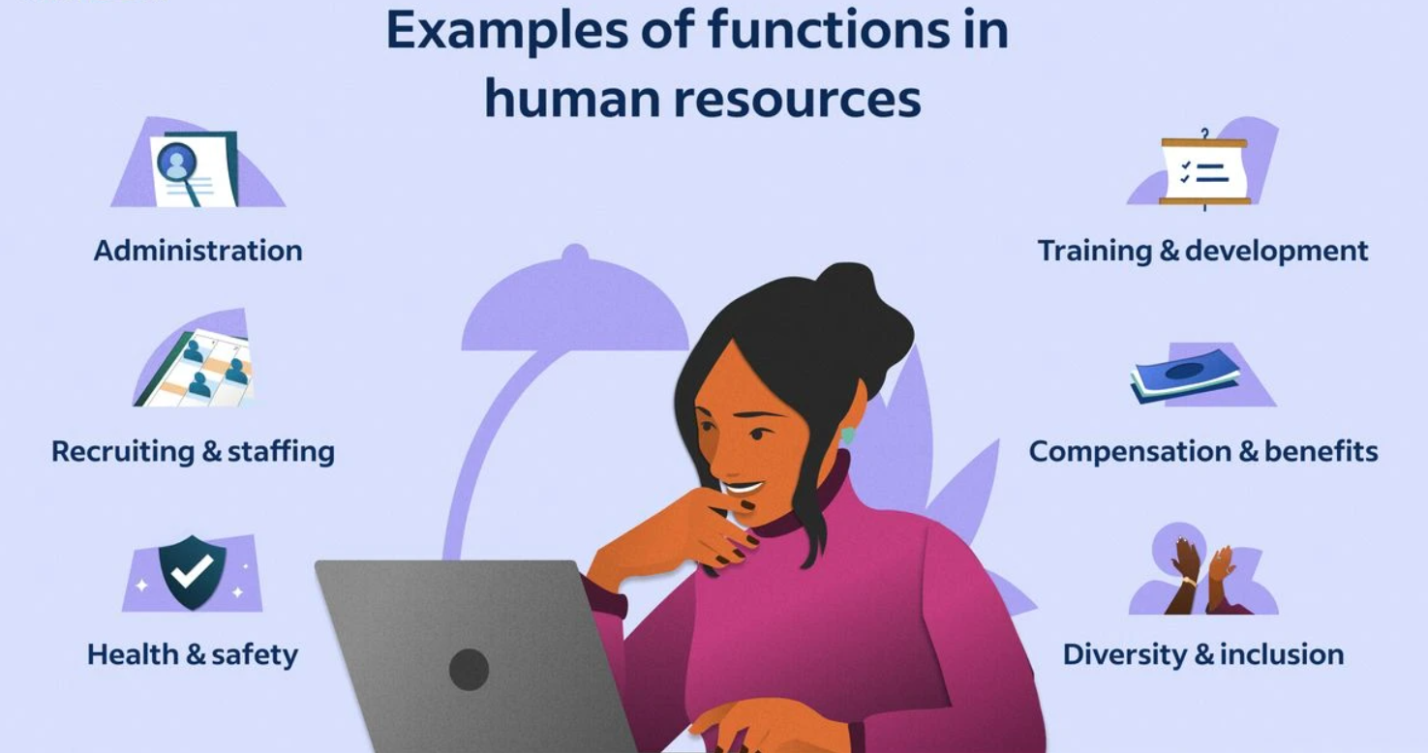
Figure 1.3.1 Functions of Human Resources (HR)

Information Technology (IT) and Technical Support Department:
Infrastructure Management: This includes managing servers, networks, hardware, and software systems to ensure seamless operation, security, and scalability.
Systems Administration: IT administrators monitor system performance, troubleshoot technical issues, install updates, and ensure data backups and recovery protocols are in place.
Cybersecurity: This team protects the organization from cyber threats by implementing firewalls, antivirus software, intrusion detection systems (IDS), and conducting regular security audits and assessments.
Software Development: IT professionals develop and maintain custom software applications, websites, and digital platforms to support internal operations and customer-facing solutions.
Technical Support: The IT helpdesk provides technical assistance, resolves user issues, and offers guidance on software usage, hardware configuration, and network connectivity.
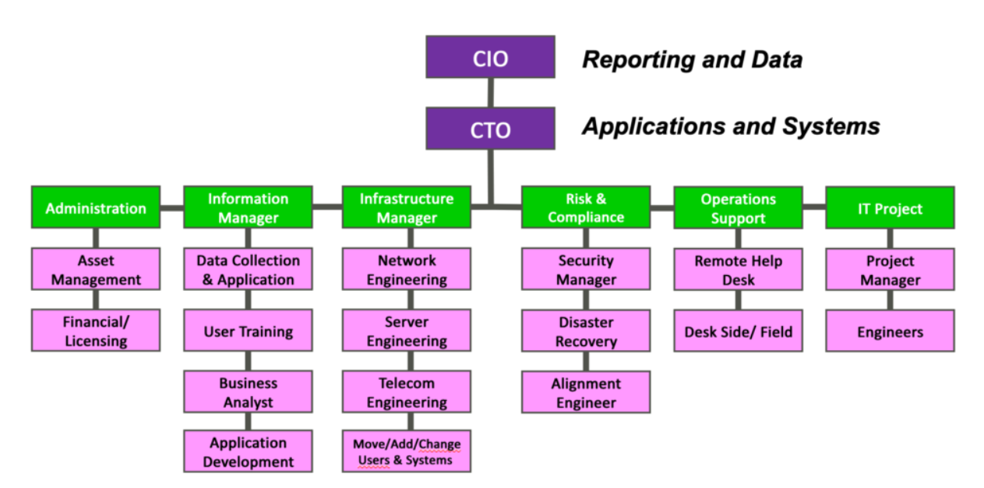
Figure 1.3.2 Information Technology (IT) Department Structure

Research and Development (R&D) Department:
Market Research and Analysis: R&D conducts market research to identify industry trends, customer preferences, and competitive landscapes to inform product development strategies.
Product Innovation: This team conceptualizes and prototypes new products, features, and services, leveraging emerging technologies and customer feedback to drive innovation.
Prototype Development: R&D builds and tests prototypes to validate concepts, assess feasibility, and gather user feedback before full-scale development and commercialization.
Intellectual Property Management: This involves securing patents, trademarks, and copyrights to protect the organization's innovations, inventions, and creative works from infringement.
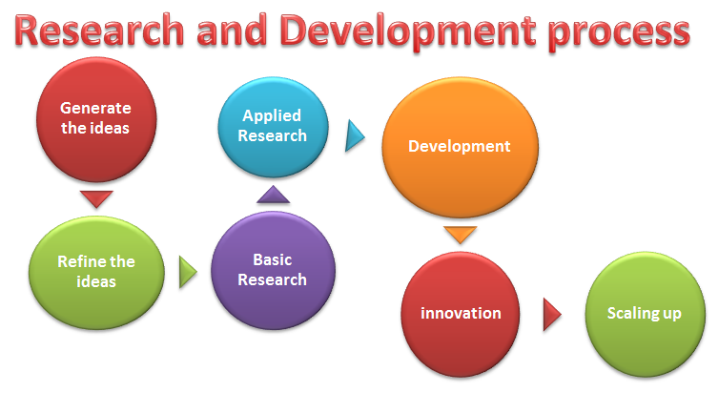
Figure1.3.3 Research & Development Process

Sales and Marketing Department:Market Segmentation and Targeting: Sales and marketing professionals identify and segment target markets based on demographics, behaviors, and preferences to tailor marketing messages and campaigns.
Lead Generation and Nurturing: This team generates leads through advertising, content marketing, and networking efforts, then nurtures those leads through email campaigns, follow-up calls, and personalized communication.
Brand Management: Sales and marketing professionals develop brand identity, messaging, and positioning strategies to differentiate EduPhoenix Solutions from competitors and build brand loyalty.
Digital Marketing: This involves leveraging digital channels such as websites, social media platforms, search engine optimization (SEO), and pay-per-click (PPC) advertising to reach and engage target audiences.
Sales Enablement: Sales enablement teams provide sales reps with the tools, resources, and training needed to effectively communicate product features, benefits, and value propositions to prospects and customers.

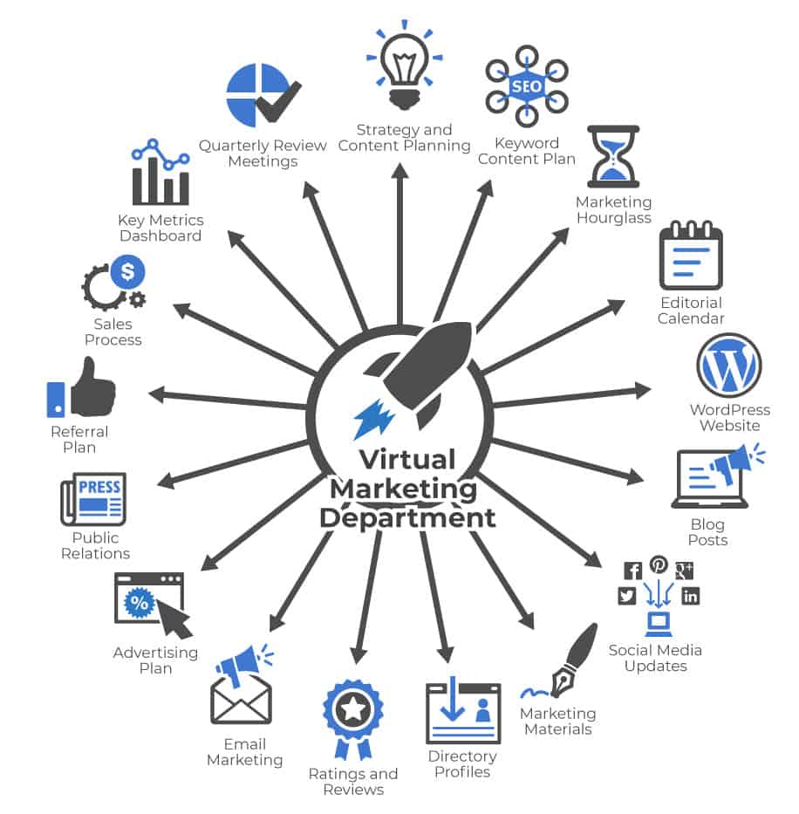
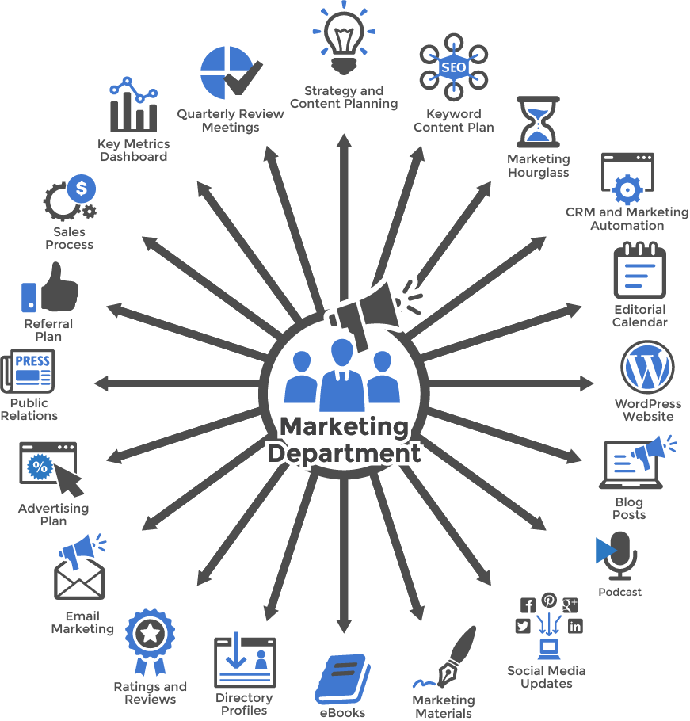
Figure 1.3.4(a) Virtual Marketing  Department | Figure 1.3.4(b) Marketing  Department

Customer Success Department:
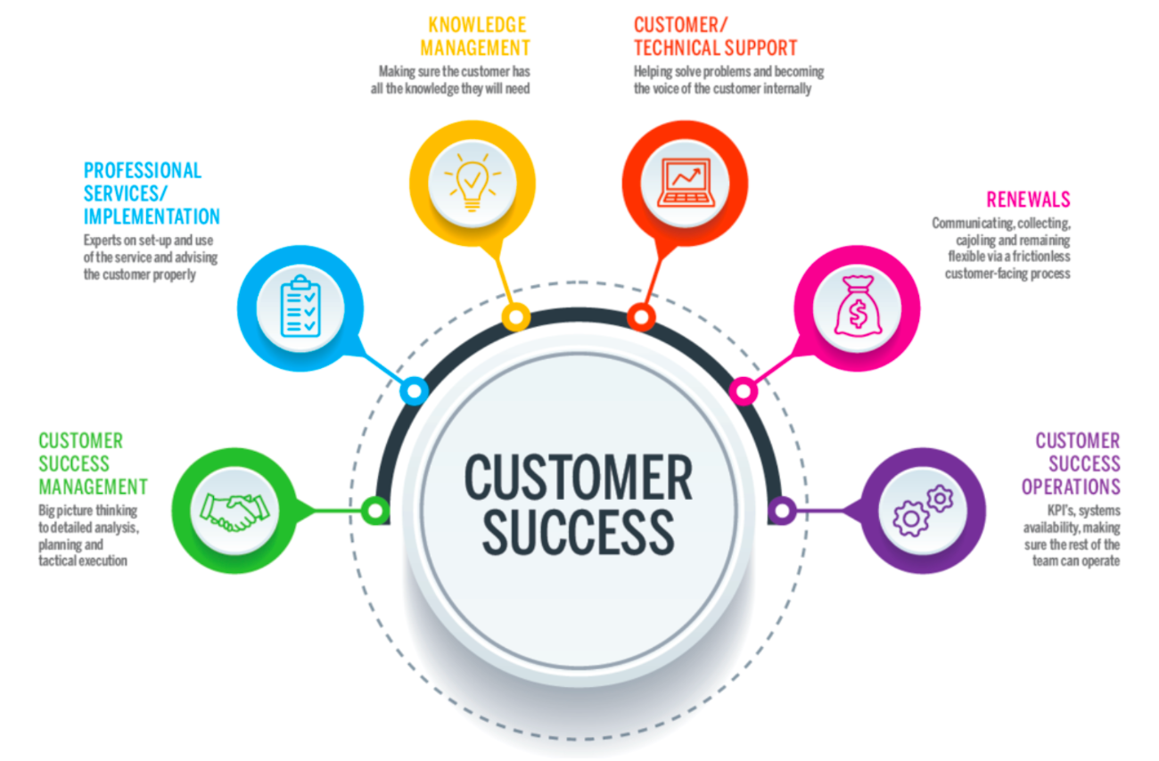
Customer Onboarding: This involves guiding new customers through the implementation process, providing training, support, and resources to ensure successful adoption and utilization of EduPhoenix Solutions.
Figure 1.3.5 Customer Success
Customer Relationship Management: Customer success managers build and nurture relationships with clients, acting as their advocate within the organization and ensuring their needs and expectations are met.
Account Management: This team is responsible for managing customer accounts, identifying upsell and cross-sell opportunities, and fostering long-term relationships to drive retention and expansion.
Customer Support: The customer support team provides responsive assistance, troubleshooting, and issue resolution to address customer inquiries, technical challenges, and service disruptions effectively.

Finance and Accounting Department:
Financial Planning and Analysis: This department is responsible for budgeting, forecasting, financial modeling, and providing insights to support strategic decision-making.
Accounts Payable and Receivable: Finance professionals manage payments to vendors, invoicing customers, and tracking receivables to ensure timely cash flow management.
Financial Reporting and Compliance: This team prepares financial statements, regulatory filings, and ensures compliance with accounting standards, tax laws, and industry regulations.
Treasury Management: Finance professionals oversee cash management, investment strategies, and risk mitigation to optimize liquidity and financial stability.

Figure 1.3.6 Finance & Accounting

Legal and Compliance Department:
Contract Management: Legal professionals draft, review, and negotiate contracts with clients, partners, and vendors to protect EduPhoenix Solutions' interests and mitigate legal risks.
Regulatory Compliance: This team ensures compliance with laws, regulations, and industry standards related to data privacy, security, intellectual property, and consumer protection.
Intellectual Property (IP) Management: Legal experts manage EduPhoenix Solutions' intellectual property portfolio, including patents, trademarks, copyrights, and trade secrets.
Risk Management: The legal and compliance department identifies, assesses, and manages legal and regulatory risks to minimize exposure and protect the organization from liabilities.
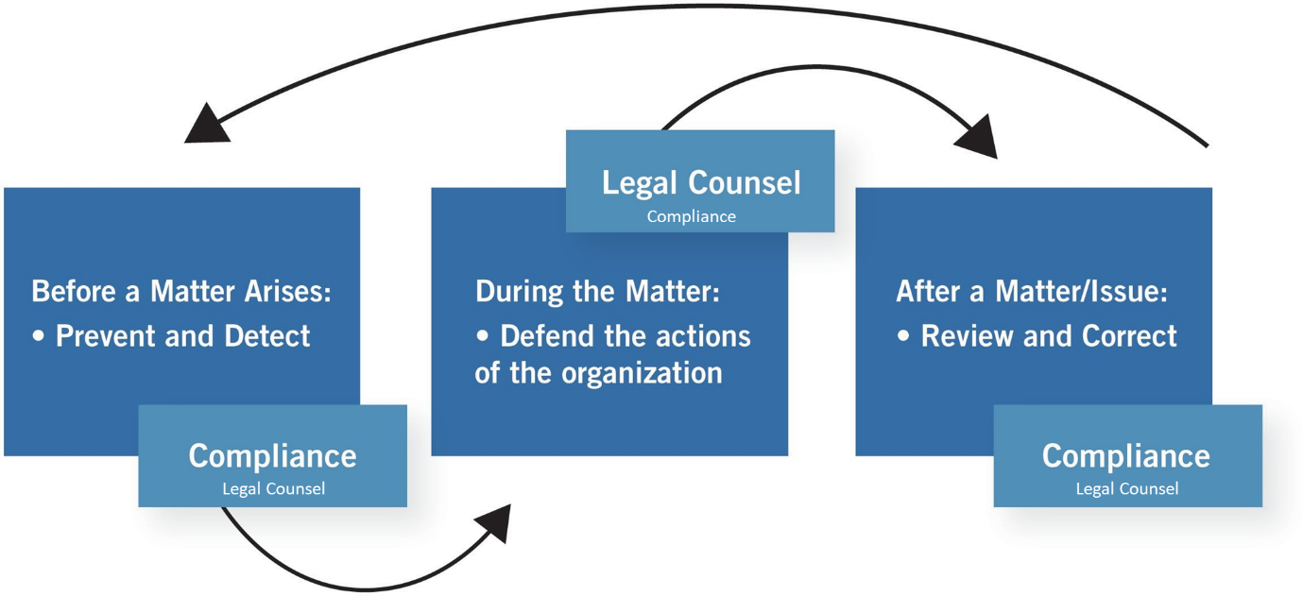
Figure 1.3.7 Legal & Compliance Procedure

Operations and Logistics Department:
Supply Chain Management: Operations professionals oversee procurement, inventory management, and logistics to ensure timely delivery of goods and services while optimizing costs and efficiency.
Facilities Management: This team maintains and manages office facilities, equipment, and infrastructure to create a safe, productive, and comfortable work environment.
Quality Assurance and Control: Operations experts develop and implement quality standards, processes, and metrics to ensure products and services meet or exceed customer expectations.

Figure 1.3.8(a) Operations  Management | Figure 1.3.8(b) Logistics

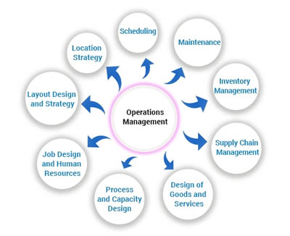
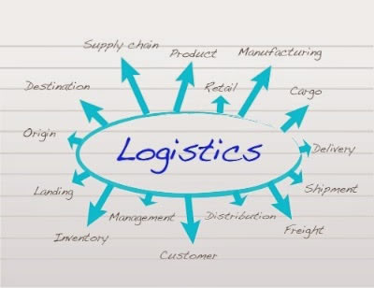
Project Management: Operations professionals coordinate cross-functional projects, allocate resources, and track progress to ensure timely completion and successful outcomes.

Customer Experience Department:
User Experience (UX) Design: This team focuses on designing intuitive, user-friendly interfaces and interactions for digital products and platforms to enhance customer satisfaction and engagement.
Customer Insights and Analytics: CX professionals analyze customer feedback, behavior data, and performance metrics to gain actionable insights and drive continuous improvement initiatives.
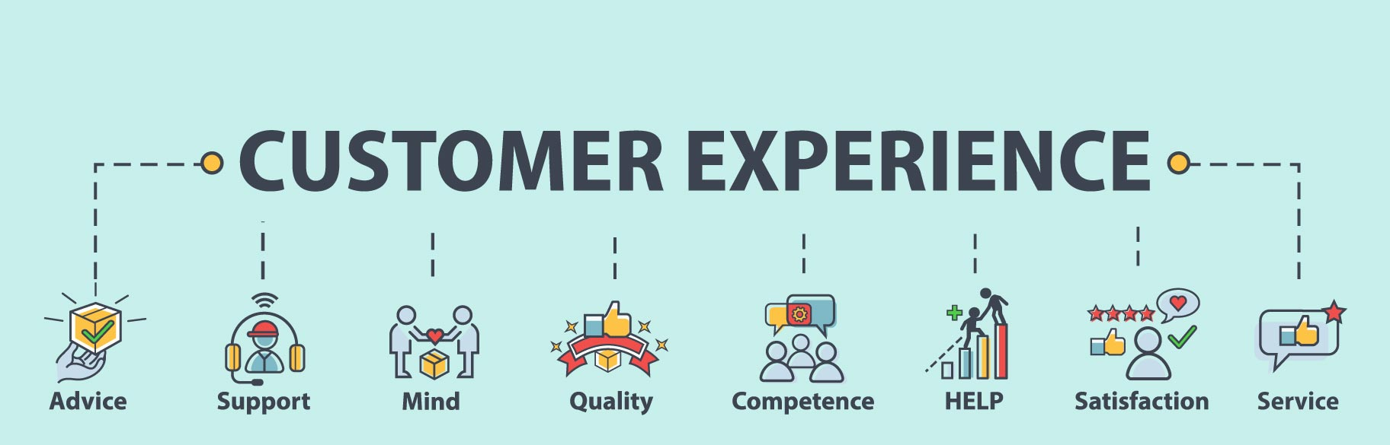
Customer Advocacy: This department represents the voice of the customer within the organization, advocating for their needs, preferences, and concerns to inform product development and decision-making.
Figure 1.3.9 Customer Experience
Customer Satisfaction and Retention: CX professionals develop strategies and programs to measure and improve customer satisfaction, loyalty, and retention rates through proactive engagement and personalized experiences.

Business Development and Partnerships Department:
Strategic Partnerships: Business development professionals identify and cultivate strategic alliances, joint ventures, and partnerships with other companies to expand market reach, access new resources, and drive growth.
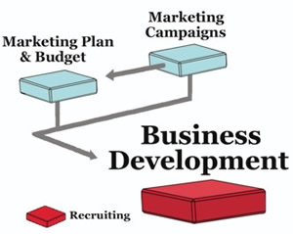
Market Expansion: This team explores new markets, geographies, and customer segments to identify growth opportunities and develop market entry strategies to capitalize on emerging trends.
Channel Development: Business development experts establish and manage distribution channels, reseller networks, and affiliate programs to extend EduPhoenix Solutions' reach and increase sales volume.
Competitive Intelligence: This department monitors competitors' activities, market trends, and industry developments to identify threats and opportunities, inform strategic decision-making, and maintain a competitive edge. Figure 1.3.10 Business Development

Quality Assurance and Testing Department:
Quality Assurance (QA) Testing is a critical function that ensures products and services meet specified quality standards before they are released to customers. This involves systematically testing various aspects of software, hardware, or other deliverables to identify defects or areas for improvement.
QA testers develop comprehensive test plans, scenarios, and scripts based on project requirements and specifications. These documents outline the testing approach, test cases, and expected outcomes for each test scenario.
Different types of testing are performed throughout the development lifecycle, including functional testing, which verifies that the system meets specified functional requirements, and regression testing, which ensures that new changes do not adversely impact existing functionality.

Figure 1.3.11(a) Quality Assurance | Figure 1.3.11(b) Testing

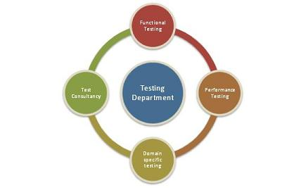
User acceptance testing (UAT) is conducted to validate the product against user expectations and requirements. This involves engaging end-users to evaluate the product's usability, accessibility, and overall user experience.
QA testers use a variety of testing techniques and tools to identify defects and bugs in the system. This may include manual testing, automated testing, performance testing, security testing, and usability testing, among others.
Throughout the testing process, QA testers document their findings, including any defects or issues discovered during testing. They work closely with development teams to prioritize and address these issues, ensuring that high-priority defects are resolved promptly.
Continuous improvement is a key aspect of QA testing, with testers regularly reviewing and refining testing processes and methodologies to enhance efficiency and effectiveness. This may involve implementing new tools, adopting best practices, and incorporating feedback from stakeholders to drive quality improvements.
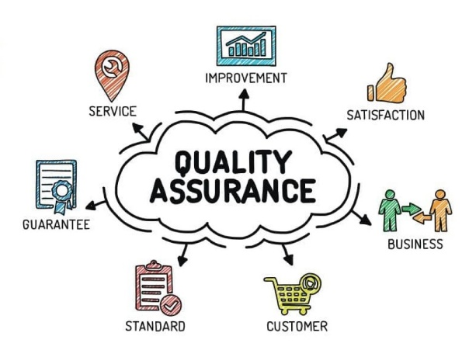
Grievance and Conflict Resolution Department:
The Grievance and Conflict Resolution department is responsible for managing disputes, grievances, and conflicts within the organization. This department serves as a neutral mediator, helping parties resolve issues in a fair and equitable manner.
One of the primary functions is to provide employees and stakeholders with a platform to express their concerns and grievances. This could involve setting up confidential reporting mechanisms, such as hotlines or online portals, where individuals can raise issues anonymously.
The department investigates complaints and conflicts thoroughly, gathering relevant information and evidence to understand the root causes of the problem. Depending on the nature of the issue, this may involve conducting interviews, reviewing documentation, or engaging in alternative dispute resolution methods like mediation or arbitration.
Once the investigation is complete, the department works towards finding a resolution that addresses the concerns of all parties involved. This could involve implementing corrective actions, revising policies or procedures, or providing training and support to prevent similar issues from arising in the future.
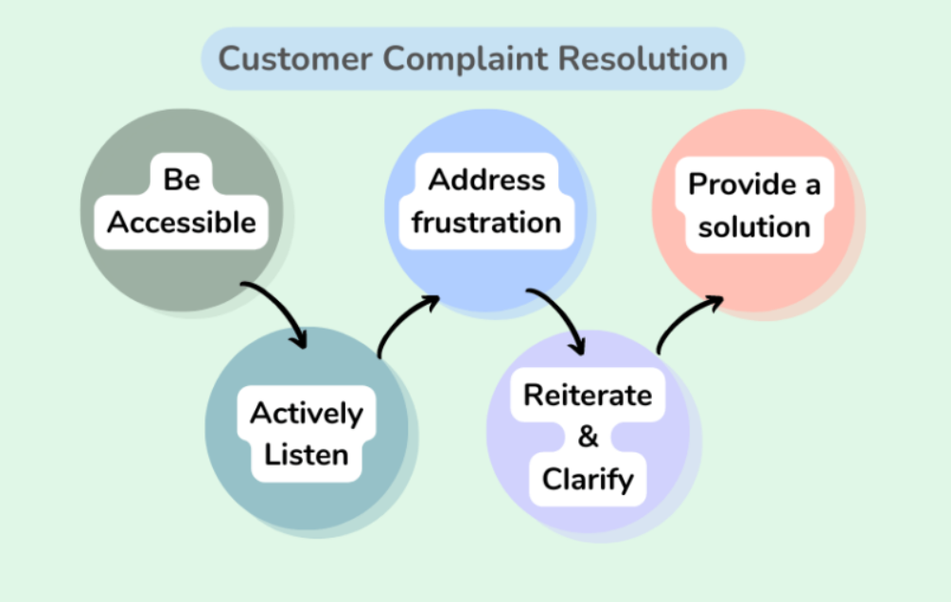
Figure 1.3.12 Customer Complaint Resolution
Additionally, the Grievance and Conflict Resolution department may play a role in promoting a positive organizational culture by fostering open communication, trust, and collaboration among employees. This includes promoting conflict resolution skills and providing resources for managing interpersonal conflicts effectively.

These departments play integral roles in ensuring the success and growth of EduPhoenix Solutions by effectively managing resources, delivering high-quality products and services, and delivers comprehensive educational solutions that empower learners, educators, and institutions to succeed in a rapidly evolving digital landscape.

  - Company Products/Applications
EduPhoenix Solutions prides itself on offering a diverse array of cutting-edge educational technology products and applications designed to cater to the evolving needs of educators and learners alike. Our commitment to innovation and excellence drives us to develop solutions that enhance teaching effectiveness, promote student engagement, and ultimately elevate the learning experience. Here's a detailed overview of our key products and applications:
- Learning Management System (LMS):
Our Learning Management System (LMS) serves as the cornerstone of our educational technology suite. This robust platform provides educators with the tools they need to create, deliver, and manage online courses and educational content seamlessly. With intuitive course creation features, comprehensive content management capabilities, and robust assessment tools, our LMS empowers educators to design dynamic and interactive learning experiences. Moreover, real-time analytics and reporting functionalities enable educators to monitor student progress and performance effectively.

- Virtual Classroom:
In today's digital age, our Virtual Classroom platform offers educators a versatile and immersive online learning environment. Equipped with video conferencing, screen sharing, interactive whiteboards, and chat functionality, this platform facilitates real-time collaboration and interaction between educators and students. Whether conducting live classes, webinars, or virtual workshops, educators can engage learners effectively and foster meaningful learning experiences. Seamless integration with our LMS ensures streamlined course delivery and administration.

- Interactive Content Authoring Tools:
Our suite of interactive content authoring tools empowers educators to create engaging and multimedia-rich learning materials with ease. Featuring user-friendly interfaces, customizable templates, and multimedia integration capabilities, these authoring tools enable educators to develop interactive presentations, quizzes, simulations, and games effortlessly. With built-in assessment and tracking features, educators can assess student comprehension and progress in real time, ensuring that learning objectives are met effectively.

- Professional Development Programs:
Recognizing the importance of continuous professional development, we offer a wide range of training courses and programs designed to enhance educators' skills and knowledge in educational technology and pedagogy. From digital literacy and blended learning to instructional design and technology integration, our professional development programs cover a diverse array of topics. Whether educators are looking to expand their expertise in specific areas or earn certifications in educational technology, our programs provide valuable opportunities for growth and advancement.
- Consultancy Services:
Our consultancy services cater to educational institutions seeking expert guidance and support in leveraging technology for teaching and learning. Our team of seasoned consultants collaborates closely with clients to assess their unique needs, develop tailored technology solutions, and provide ongoing training and support. From strategic planning and needs analysis to implementation and evaluation, our consultancy services empower institutions to maximize the impact of educational technology and achieve their educational goals effectively.

- IoT Projects:
Internet of Things (IoT) projects involve the integration of physical devices, sensors, and software applications to enable connectivity and data exchange. These projects often focus on leveraging IoT technologies to create smart systems, automate processes, and gather insights from real-world data. Eduphoenix Solutions offers a range of IoT projects aimed at providing hands-on learning experiences to students and professionals.
These projects typically cover areas such as:
Sensor Integration: Students learn to integrate various sensors such as temperature sensors, humidity sensors, motion sensors, and environmental sensors into IoT devices and systems.
Data Acquisition and Processing: Projects involve collecting data from sensors and processing it using microcontrollers or single-board computers like Arduino, Raspberry Pi, or ESP8266/ESP32.
Connectivity and Communication: Students explore different communication protocols such as Wi-Fi, Bluetooth, Zigbee, and LoRa to enable connectivity between IoT devices and networks.
IoT Applications: Projects may focus on developing IoT applications for smart homes, smart cities, industrial automation, healthcare monitoring, environmental monitoring, agriculture, and more.
Cloud Integration: Integration with cloud platforms such as AWS IoT, Google Cloud IoT, or Microsoft Azure IoT enables students to store, analyze, and visualize IoT data, as well as implement cloud-based services like remote monitoring and control.
Security and Privacy: Emphasis is placed on implementing security measures such as encryption, authentication, and access control to protect IoT systems from cyber threats and ensure data privacy.

- AI-ML Projects:
Artificial Intelligence (AI) and Machine Learning (ML) projects involve the development and application of algorithms and models to analyze data, make predictions, and automate tasks without explicit programming instructions. These projects harness the power of AI and ML techniques to solve complex problems, optimize processes, and extract insights from data. Eduphoenix Solutions offers a variety of AI-ML projects aimed at fostering understanding and proficiency in these transformative technologies.
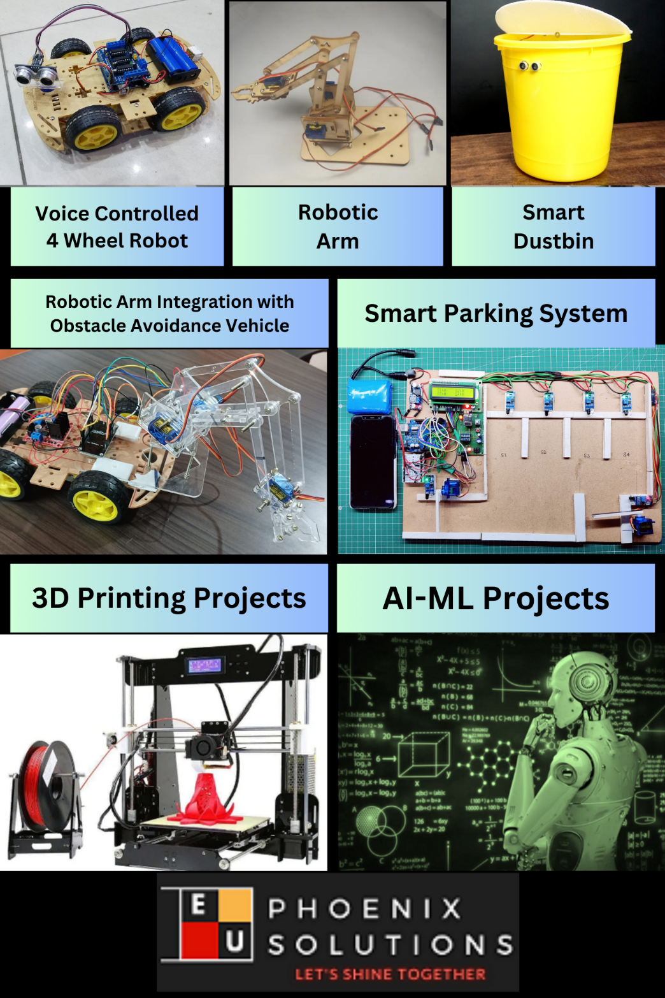

Figure 1.4.1 Company Products

Key components of AI-ML projects include:
Data Collection and Preparation: Projects begin with data collection from various sources such as sensors, databases, or web APIs. Data preprocessing techniques are then applied to clean, transform, and prepare the data for analysis.
Algorithm Selection and Model Development: Students explore different AI and ML algorithms such as regression, classification, clustering, neural networks, and deep learning to build predictive models and solve specific problems.
Model Training and Evaluation: The models are trained using abelled data, and their performance is evaluated using metrics such as accuracy, precision, recall, and F1-score. Hyperparameter tuning and cross-validation techniques are applied to optimize model performance.
Deployment and Integration: Once trained and evaluated, the models are deployed into production environments and integrated with existing systems or applications to deliver real-world value. This may involve deploying models on edge devices, cloud platforms, or IoT devices.

Overall, IoT and AI-ML projects offered by EduPhoenix Solutions provide participants with practical experience, critical thinking skills, and technical expertise in emerging technologies, preparing them for careers in the rapidly evolving fields of IoT and AI-ML.

CHAPTER 2
DOMAIN: INTERNET OF THINGS (IOT)

2.1 Introduction
The Internet of Things (IoT) is a revolutionary technology that enables everyday objects and devices to connect, collect, and exchange data over the internet. It encompasses a vast ecosystem of interconnected devices, sensors, and systems, facilitating seamless communication and automation across various domains. Here's a brief overview of IoT and its key components:
- Definition and Concept:
IoT refers to the network of physical devices, vehicles, appliances, and other objects embedded with sensors, software, and connectivity capabilities to collect and exchange data.
The core concept of IoT revolves around enabling objects to communicate and interact with each other autonomously, leading to increased efficiency, productivity, and convenience.
- Key Components:
Sensors and Actuators: Sensors capture real-world data such as temperature, humidity, motion, and light, while actuators enable devices to perform physical actions based on input data.
Connectivity Technologies: IoT devices use various communication protocols and technologies such as Wi-Fi, Bluetooth, Zigbee, and cellular networks to transmit data to cloud platforms or other devices.
Cloud Computing: Cloud-based platforms play a crucial role in IoT by providing storage, processing, and analytics capabilities for handling large volumes of data generated by connected devices.
Data Analytics and Machine Learning: IoT data is analyzed using advanced analytics techniques and machine learning algorithms to derive valuable insights, predict future trends, and optimize decision-making processes.
Security and Privacy: As IoT devices collect and transmit sensitive data, ensuring robust security measures such as encryption, authentication, and access control is essential to protect against cyber threats and safeguard user privacy.
- Applications and Use Cases:
IoT has diverse applications across industries such as healthcare, agriculture, manufacturing, transportation, smart cities, and home automation.
Examples of IoT use cases include remote patient monitoring in healthcare, precision agriculture for crop management, predictive maintenance in manufacturing, smart transportation systems, and energy-efficient smart homes.
- Challenges and Opportunities:
While IoT offers numerous benefits, including increased efficiency, cost savings, and enhanced decision-making, it also presents challenges related to security, interoperability, scalability, and data privacy.
Addressing these challenges requires collaboration between technology providers, policymakers, and industry stakeholders to develop standards, regulations, and best practices for IoT deployment.
During the internship at EduPhoenix Solutions, interns have the opportunity to explore the fascinating world of IoT through hands-on projects, workshops, and mentorship from experienced professionals. They gain practical experience in developing IoT solutions, working with sensors, microcontrollers, communication protocols, cloud platforms, and data analytics tools. Through collaborative projects and real-world applications, interns develop the skills and expertise needed to excel in the field of IoT and contribute to innovative IoT projects and initiatives.
IoT holds immense potential to transform industries, improve quality of life, and drive innovation across various domains. By understanding the fundamentals of IoT and gaining practical experience in developing IoT solutions, interns at EduPhoenix Solutions can prepare themselves for exciting career opportunities in this dynamic and rapidly evolving field. Through continuous learning, experimentation, and collaboration, interns can become proficient IoT professionals capable of leveraging technology to solve complex challenges and create meaningful impact in the world.
2.2 Overview
The Internet of Things (IoT) is a transformative technology that connects everyday objects to the internet, enabling them to collect, exchange, and analyze data autonomously. At EduPhoenix Solutions, interns gain insights into the diverse applications, components, and implications of IoT through hands-on learning experiences and mentorship from industry experts.
- Definition and Scope:
IoT refers to the network of interconnected devices, sensors, actuators, and software applications that communicate and interact with each other over the internet.
The scope of IoT extends across various domains, including smart homes, healthcare, agriculture, transportation, industrial automation, and environmental monitoring.
- Key Components:
Devices and Sensors: IoT devices, such as smart sensors, cameras, wearables, and actuators, collect data from the physical environment.
Connectivity: IoT relies on communication protocols like Wi-Fi, Bluetooth, Zigbee, LoRa, and cellular networks to transmit data between devices and to the cloud.
Cloud Computing: Cloud platforms provide storage, processing, and analytics capabilities for managing large volumes of IoT data and deploying scalable applications.
Edge Computing: Edge devices and gateways perform data processing and analysis locally, reducing latency and bandwidth requirements for real-time applications.
- Applications and Use Cases:
Smart Home Automation: IoT enables homeowners to remotely control and automate lighting, heating, security systems, and appliances for improved comfort, energy efficiency, and security.
Healthcare Monitoring: IoT devices monitor patients' vital signs, medication adherence, and activity levels, enabling remote healthcare delivery, chronic disease management, and emergency response.
Industrial IoT (IIoT): IoT solutions optimize manufacturing processes, asset tracking, predictive maintenance, and supply chain management, enhancing productivity, efficiency, and safety in industrial environments.
Smart Agriculture: IoT sensors monitor soil moisture, temperature, and crop health, enabling precision irrigation, pest management, and yield optimization for sustainable agriculture practices.
Connected Vehicles: IoT connectivity enables vehicle-to-vehicle (V2V) and vehicle-to-infrastructure (V2X) communication, improving road safety, traffic management, and autonomous driving capabilities.
- Challenges and Considerations:
Security and Privacy: IoT devices are vulnerable to cyber attacks, data breaches, and privacy violations, necessitating robust security measures such as encryption, authentication, and access controls.
Interoperability: The diversity of IoT devices, protocols, and platforms poses challenges for interoperability, data integration, and seamless communication across heterogeneous environments.
Scalability and Reliability: IoT deployments must scale to accommodate millions of connected devices while ensuring reliability, low latency, and high availability for mission-critical applications.
Data Governance: Managing and analyzing large volumes of IoT data require effective data governance strategies, including data storage, processing, visualization, and compliance with regulatory requirements.
- Future Trends and Opportunities:
5G and Edge Computing: The rollout of 5G networks and edge computing infrastructure will accelerate the adoption of IoT applications, enabling ultra-low latency, high-bandwidth connectivity for real-time applications.
AI and Machine Learning: Integration of AI and machine learning algorithms with IoT data analytics will enable predictive maintenance, anomaly detection, and personalized insights, driving innovation in various industries.
Blockchain Technology: Blockchain-based solutions offer decentralized, tamper-resistant data storage and transaction capabilities, enhancing the security, transparency, and trustworthiness of IoT ecosystems.
Sustainable IoT: Sustainable IoT solutions focus on energy efficiency, resource optimization, and environmental monitoring to address climate change and promote sustainable development goals.
Through experiential learning and collaborative projects at EduPhoenix Solutions, interns explore the multifaceted landscape of IoT, gaining practical skills and insights to address real-world challenges and opportunities in the dynamic field of IoT innovation.

CHAPTER 3
INTERNSHIP TASK/DAILY-LOGS

CHAPTER 4
PROJECT
4.1 On Job Training (OJT) - 1
Project 1: Obstacle Avoidance Robot Car
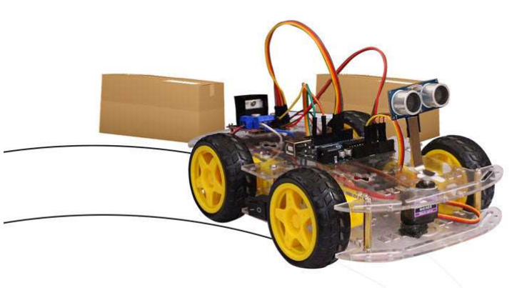
Figure 4.1 Obstacle Avoidance Robot Car
Introduction
The ESP-Based Obstacle Avoidance Robot project endeavours to create an autonomous robotic system capable of maneuvering through indoor spaces while evading obstacles. By harnessing the power of the ESP8266 microcontroller, the robot will integrate various sensors for obstacle detection and execute sophisticated algorithms for instantaneous decision-making. The project encompasses mechanical design, sensor integration, algorithm development, and microcontroller programming to achieve autonomous navigation. Once completed, the robot will showcase its ability to navigate autonomously, opening doors for applications in surveillance, education, and research. This initiative offers engineering students practical exposure to robotics, embedded systems, and sensor technology, fostering their expertise and innovation in the realm of autonomous robotics.
Background
The project's background reflects the evolution of robotics technology, transitioning from industrial automation to the development of sophisticated autonomous systems. With the introduction of the ESP8266 microcontroller, embedded systems and IoT applications have witnessed a paradigm shift, owing to its compact size, low power consumption, and extensive functionality. Obstacle avoidance algorithms play a crucial role in robotics, ensuring safe navigation in dynamic environments. Understanding these advancements sets the foundation for addressing challenges and exploring opportunities in designing an ESP-based obstacle avoidance robot, enabling safe and efficient navigation in indoor environments.
Design & Components
The design of the ESP-Based Obstacle Avoidance Robot revolves around integrating various components to create a functional and efficient autonomous system. Here's a brief overview of the key components:
- ESP8266 Microcontroller
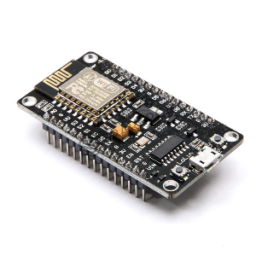
The ESP8266 serves as the central processing unit, responsible for controlling the robot's behaviour, processing sensor data, and executing obstacle avoidance algorithms. Its Wi-Fi capabilities also enable remote control and communication with other devices.

- DHT11 Sensor
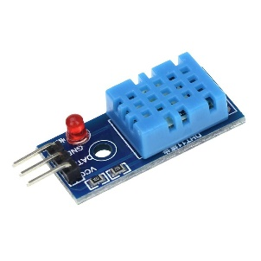
The DHT11 sensor provides environmental data, allowing the robot to monitor temperature and humidity levels in its surroundings.

- HC-05 Bluetooth Module
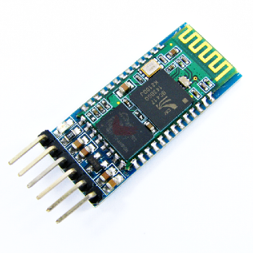
The HC-05 module facilitates wireless communication between the robot and external devices, enabling remote control and data exchange via Bluetooth.

- L298D Motor Driver Shield
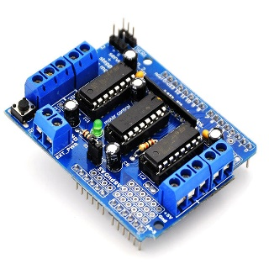
The L298D motor driver shield controls the movement of the robot's motors, providing sufficient power and control to drive the wheels effectively.

- BO Motor
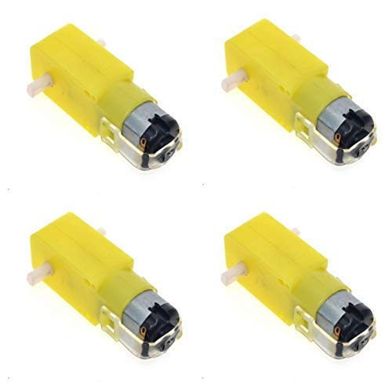
BO (brushed DC) motors are commonly used for robotic applications due to their simplicity and efficiency. They provide the necessary propulsion for the robot's movement.


- Battery Holder
The battery holder securely houses the power source, ensuring a stable supply of electricity to the robot's components.

- Lithium-Ion Battery
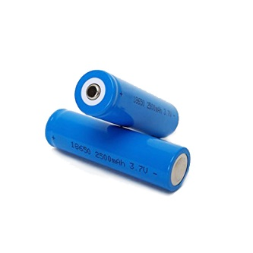
Lithium-ion batteries offer high energy density and rechargeable capabilities, providing long-lasting power for extended operation periods.


- BO Wheels
BO wheels are specifically designed for robotic applications, offering durability, traction, and stability during movement.

- 4-Wheel Chassis
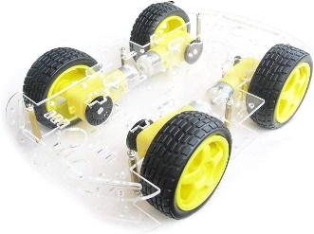
The 4-wheel chassis provides a stable platform for mounting the components and ensures smooth movement and maneuverability.

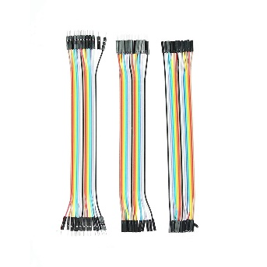
- Jumper Cables
Jumper cables are used for connecting various components, facilitating electrical connections and signal transmission.

Assembly & Construction
The assembly and construction of the ESP-based obstacle avoidance robot involve integrating various components to create a functional and efficient autonomous system. Step-by-Step Assembly Instructions:
I. Chassis Setup: Begin by assembling the 4-wheel chassis, ensuring stability and durability for the robot's movement.
II. Motor Integration: Mount the BO motors onto the chassis and connect them to the L298D motor driver shield. Ensure proper alignment and secure attachment to facilitate smooth movement.
III. Microcontroller Installation: Install the ESP8266 microcontroller onto the chassis, providing easy access to its GPIO pins and power supply.
IV. Sensor Mounting: Position the DHT11 temperature and humidity sensor on the chassis, ensuring optimal placement for accurate environmental monitoring.
V. Bluetooth Module Connection: Connect the HC-05 Bluetooth module to the ESP8266 microcontroller using jumper cables, enabling wireless communication for remote control and data exchange.
VI. Power Supply Setup: Install the lithium-ion battery into the battery holder and connect it to the power input of the L298D motor driver shield. Ensure secure connections and proper voltage regulation.
VII. Wheel Attachment: Attach the BO wheels to the motors, ensuring proper alignment and smooth rotation. Test the movement of the wheels to ensure they operate effectively.
VIII. Wiring and Connections: Use jumper cables to establish connections between the components, including the microcontroller, sensors, motor driver, and power supply. Double-check the connections to avoid any loose or incorrect wiring.
IX. Final Testing: Power up the robot and test its functionality, including motor movement, sensor readings, and Bluetooth communication. Make any necessary adjustments to ensure proper operation.
Working Principle
The working principle of the ESP-based obstacle avoidance robot involves several key procedures:
1 Initialization and Setup Procedures Upon startup, the ESP8266 microcontroller initializes the GPIO pins, sensors, motor driver, and other components. It configures the ultrasonic sensor to emit and receive ultrasonic waves while calibrating the motor driver for precise control of the DC motors.
2 Sensor Data Acquisition and Processing The ultrasonic sensor continuously measures distances to obstacles in the robot's path. The ESP8266 microcontroller reads these distance measurements and processes them to detect obstacles and calculate their proximity to the robot.
3 Decision-Making Algorithms Using the sensor data, the microcontroller executes decision-making algorithms to determine the robot's movements. If an obstacle is detected within a predefined range, the microcontroller generates motor control commands to adjust the robot's trajectory and avoid collisions.
4 Motor Control Mechanisms The motor control mechanisms on the ESP8266 microcontroller regulate the speed and direction of the DC motors. By adjusting motor speeds and directions based on obstacle detection, the robot can navigate autonomously while avoiding obstacles in its path
Conclusion
In conclusion, ESP-based obstacle avoidance robots represent a promising and versatile platform for addressing a wide range of challenges and opportunities in various industries and domains. With their ability to navigate autonomously while avoiding obstacles, these robots offer valuable capabilities for applications such as surveillance, logistics, healthcare, and more. As technology continues to advance and new innovations emerge, the future holds immense potential for further enhancing the autonomy, intelligence, and adaptability of ESP-based obstacle avoidance robots, unlocking new possibilities for automation, efficiency, and safety in diverse environments.

Use Case: On Job Training (OJT) - 1
Title: Obstacle Avoidance Robot Car Project
Actors:
Intern (Trainee)
Mentor (Supervisor)
Description:
The project involves the development of an obstacle avoidance robot car using Internet of Things (IoT) technology. The intern, as part of their On Job Training (OJT) - 1 program, collaborates with a mentor who guides them through the project's implementation. The aim is to design and construct a robot car capable of autonomously navigating through an environment while avoiding obstacles in its path.
Preconditions:
Intern has basic knowledge of programming languages such as C++ and Python.
Mentor has expertise in IoT and robotics.
Main Flow:
- Requirement Analysis:
Intern and mentor discuss the project requirements and objectives.
Define the functionalities and specifications of the obstacle avoidance robot car.
- Hardware Selection and Assembly:
Intern researches and selects appropriate hardware components such as motors, sensors, microcontrollers, and chassis.
Assemble the selected hardware components to build the robot car.
- Sensor Integration:
Intern integrates sensors such as ultrasonic or infrared sensors to detect obstacles in the environment.
Write code to interface the sensors with the microcontroller board.
- Programming:
Develop code to control the movement of the robot car based on sensor inputs.
Implement algorithms for obstacle detection and avoidance.
- Testing and Debugging:
Conduct testing to verify the functionality of the obstacle avoidance system.
Debug code and hardware issues as necessary.
- Documentation:
Document the design, implementation, and testing processes.
Prepare user manuals and technical documentation for future reference.
Postconditions:
Successful implementation of an obstacle avoidance robot car.
Intern gains practical experience in IoT-based project development.
Mentor provides feedback and evaluation of the intern's performance.
Alternative Flows:
If the selected hardware components are not available, the intern may research alternative options.
In case of technical challenges, the mentor assists the intern in troubleshooting and finding solutions.
This use case demonstrates how an intern, under the guidance of a mentor, can successfully complete a project involving IoT technology, enhancing their skills and knowledge in the field of robotics and automation.

4.2 On Job Training (OJT) - 2
Project 2: Robotic Arm Integration with 4 Wheel Chassis
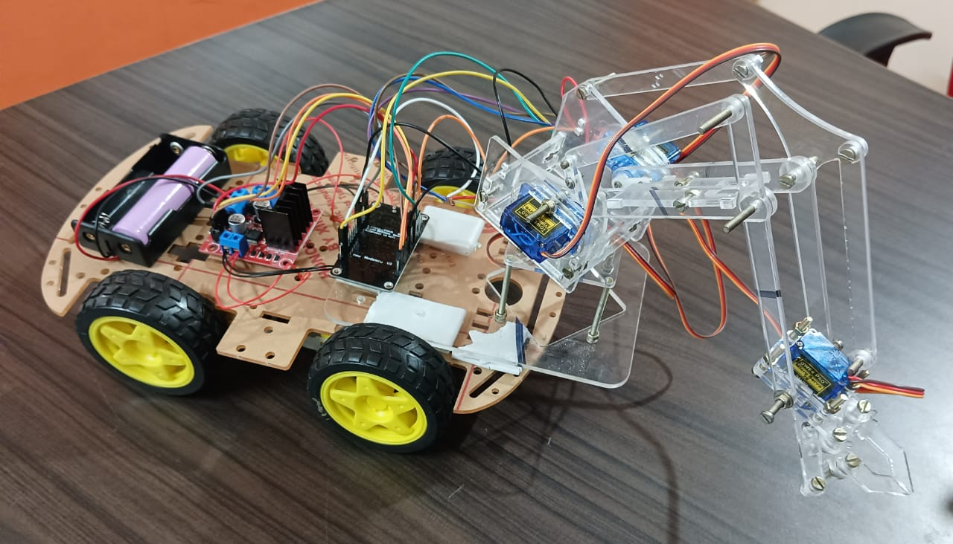
Figure 4.2 Robotic Arm Integration with 4 Wheel Chassis
Introduction
By harnessing the capabilities of IoT and incorporating efficient wheeled locomotion, this robotic arm represents a significant advancement in robotics technology. Its versatility, mobility, and remote operability make it a valuable tool in industrial automation, logistics, and other fields where precision and efficiency are paramount. Through ongoing research and development, the potential applications and impact of such robotic systems continue to expand, driving innovation and progress in the field of robotics.
The purpose of the project centered around the integration of a robotic arm with a four-wheel drive platform is to develop a versatile and capable robotic system capable of performing various tasks in dynamic and challenging environments.
Background
The integration of robotic arms with four-wheel drive platforms combines the manipulation capabilities of the robotic arm with the mobility and versatility of the four-wheel drive platform. This integration enables robotic systems to perform a wide range of tasks, including object manipulation, navigation, obstacle avoidance, and interaction with the environment. By leveraging the strengths of both components, integrated robotic systems can operate in dynamic and unstructured environments, making them suitable for applications in agriculture, search and rescue, defense, and assistive technologies.

Design & Components
The design of the ESP-Based Obstacle Avoidance Robot revolves around integrating various components to create a functional and efficient autonomous system. Here's a brief overview of the key components:
- ESP8266 Microcontroller
The ESP8266 serves as the central processing unit, responsible for controlling the robot's behaviour, processing sensor data, and executing obstacle avoidance algorithms. Its Wi-Fi capabilities also enable remote control and communication with other devices.

- DHT11 Sensor
The DHT11 sensor provides environmental data, allowing the robot to monitor temperature and humidity levels in its surroundings.

- HC-05 Bluetooth Module
The HC-05 module facilitates wireless communication between the robot and external devices, enabling remote control and data exchange via Bluetooth.

- L298D Motor Driver Shield
The L298D motor driver shield controls the movement of the robot's motors, providing sufficient power and control to drive the wheels effectively.

- BO Motor
BO (brushed DC) motors are commonly used for robotic applications due to their simplicity and efficiency. They provide the necessary propulsion for the robot's movement.

- Battery Holder
The battery holder securely houses the power source, ensuring a stable supply of electricity to the robot's components.

- Lithium-Ion Battery
Lithium-ion batteries offer high energy density and rechargeable capabilities, providing long-lasting power for extended operation periods.

- BO Wheels
BO wheels are specifically designed for robotic applications, offering durability, traction, and stability during movement.

- 4-Wheel Chassis
The 4-wheel chassis provides a stable platform for mounting the components and ensures smooth movement and maneuverability.

- Jumper Cables
Jumper cables are used for connecting various components, facilitating electrical connections and signal transmission.

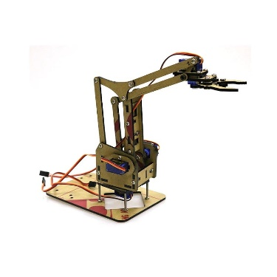
- Robotic Arm
The main component responsible for picking and placing objects. It consists of multiple joints and end-effectors to facilitate movement and manipulation.

Assembly & Construction
The assembly and construction of the ESP-based obstacle avoidance robot involve integrating various components to create a functional and efficient autonomous system.
Step-by-Step Assembly Instructions:
- Chassis Setup: Begin by assembling the 4-wheel chassis, ensuring stability and durability for the robot's movement.
- Motor Integration: Mount the BO motors onto the chassis and connect them to the L298D motor driver shield. Ensure proper alignment and secure attachment to facilitate smooth movement.
- Microcontroller Installation: Install the ESP8266 microcontroller onto the chassis, providing easy access to its GPIO pins and power supply.
- Sensor Mounting: Position the DHT11 temperature and humidity sensor on the chassis, ensuring optimal placement for accurate environmental monitoring.
- Bluetooth Module Connection: Connect the HC-05 Bluetooth module to the ESP8266 microcontroller using jumper cables, enabling wireless communication for remote control and data exchange.
- Power Supply Setup: Install the lithium-ion battery into the battery holder and connect it to the power input of the L298D motor driver shield. Ensure secure connections and proper voltage regulation.
- Wheel Attachment: Attach the BO wheels to the motors, ensuring proper alignment and smooth rotation. Test the movement of the wheels to ensure they operate effectively.
- Wiring and Connections: Use jumper cables to establish connections between the components, including the microcontroller, sensors, motor driver, and power supply. Double-check the connections to avoid any loose or incorrect wiring.
- Mechanical Integration: The robotic arm is securely mounted onto the four-wheel-drive platform using appropriate mounting brackets or fixtures. This ensures stability and prevents unwanted movement during operation.
- Electrical Connection: Electrical components, including motors, sensors, and microcontrollers, are connected according to the system's electrical schematic. Wiring harnesses are carefully routed to minimize interference and ensure reliability.
- Mounting of Components: Other necessary components, such as the power source (battery), motor drivers, and control interfaces, are mounted onto the platform. These components are positioned strategically to optimize weight distribution and balance.
- Testing and Calibration: Once the mechanical and electrical components are assembled, the system undergoes thorough testing and calibration. This includes verifying the functionality of each motor and sensor, testing communication between the microcontroller and user interface, and fine-tuning control parameters.
- Safety Measures: Safety features, such as emergency stop buttons or limit switches, are incorporated into the design to ensure safe operation and prevent accidents or damage to the system.
- Integration with User Interface: The robotic arm's control interface, whether it be a mobile app or computer software, is integrated with the system. This allows users to interact with the robotic arm and command it to perform various tasks remotely.
- Finalization: Once all components are assembled, tested, and integrated, the system is finalized. Any remaining adjustments or modifications are made to optimize performance and ensure reliability.
- Final Testing: Power up the robot and test its functionality, including motor movement, sensor readings, and Bluetooth communication. Make any necessary adjustments to ensure proper operation.
Working Principle
The working principle of the integrated robotic arm with a four-wheel drive platform involves coordinated control and interaction between the robotic arm and the chassis to accomplish various tasks efficiently. Here's how it operates:
- Command Input: The user inputs commands through a control interface, such as a mobile application or a remote-control device. These commands specify the desired actions for both the robotic arm and the chassis.
- Command Processing: The commands are processed by the microcontroller unit (MCU) onboard the robot. The MCU interprets the commands and generates corresponding control signals for the robotic arm and the chassis.
- Robotic Arm Control: The control signals for the robotic arm are sent to the servo motors or actuators responsible for its movement. These signals determine the position, orientation, and actions of the robotic arm, such as picking up or placing objects.
- Chassis Control: Simultaneously, the control signals for the chassis are transmitted to the motor drivers controlling the wheels. These signals dictate the speed and direction of each wheel, enabling the robot to move forward, backward, or turn left and right.
- Synchronization: To ensure seamless operation, the movements of the robotic arm are synchronized with the motion of the chassis. For example, when the robot moves forward, the robotic arm may adjust its position to interact with objects in the path of the robot.
- Feedback and Adjustment: Sensors integrated into the system provide feedback on the robot's environment and performance. This feedback enables the system to make real-time adjustments to its movements and actions, ensuring safe and efficient operation.
- Task Execution: The integrated robotic system executes the specified tasks based on the user's commands. This may include navigating through obstacles, picking up objects, delivering payloads, or performing other predefined actions.
- Continual Operation: The robotic system continues to operate autonomously, executing tasks as directed by the user or following preprogrammed instructions. It can adapt to changes in its environment and respond dynamically to new commands or stimuli.
Overall, the working principle of the integrated robotic arm with a four-wheel drive platform involves precise coordination and control to achieve desired outcomes effectively and autonomously. By combining the capabilities of both systems, the integrated robot can perform a wide range of tasks in diverse environments with agility and accuracy.
Conclusion
In conclusion, this study underscores several pivotal findings that underscore the significance and impact of integrating robotic arms with a four-wheel drive platform.
Firstly, the capability to lift and move heavy objects stands out as a primary advantage. By leveraging the mechanical strength of the robotic arm and the mobility afforded by the four-wheel drive platform, the system enables the handling of substantial loads with ease and efficiency.
Moreover, the system's mobility plays a crucial role in its utility. The ability to traverse various terrains and navigate through different environments enhances its practicality and versatility, making it suitable for a wide range of applications.
Furthermore, the integration of robotic arms with the four-wheel drive platform contributes to increased productivity, safety, efficiency, and product quality. By automating tasks traditionally performed by manual labor, the system reduces the risk of accidents, improves operational efficiency, and enhances the consistency and precision of outputs.

Use Case 2: On Job Training (OJT) - 2
Title: Robotic Arm Integration with 4 Wheel Chassis Project
Actors:
Intern (Trainee)
Mentor (Supervisor)
Description:
The project entails integrating a robotic arm with a 4-wheel chassis platform, combining mechanical and electronic components to create a versatile robotic system. The intern, as part of their On Job Training (OJT) - 2 program, collaborates with a mentor who provides guidance and support throughout the project's execution. The objective is to develop a robotic system capable of performing tasks such as pick-and-place operations or object manipulation with mobility provided by the chassis.
Preconditions:
Intern has basic knowledge of robotics, microcontrollers, and motor control.
Mentor possesses expertise in robotics, mechatronics, and electronic systems.
Main Flow:
- Requirement Analysis:
Intern and mentor discuss project requirements, functionalities, and objectives.
Define the specifications for the robotic arm and the 4-wheel chassis integration.
- Hardware Selection and Integration:
Intern researches and selects appropriate robotic arm components (e.g., servo motors, gripper mechanism) and 4-wheel chassis platform.
Integrate the selected hardware components to create a unified robotic system.
- Sensor Integration and Motor Control:
Incorporate sensors (e.g., proximity sensors, encoders) for object detection and feedback.
Develop motor control algorithms to synchronize the movement of the robotic arm and chassis.
- Programming and Control Interface:
Write code to control the robotic arm and chassis movements.
Implement a user interface for controlling the system, potentially using a graphical interface or wireless communication.
- Testing and Calibration:
Conduct testing to ensure proper functioning of the integrated system.
Calibrate sensors and fine-tune motor control parameters for optimal performance.
- Documentation and Training:
Document the design, assembly, and programming processes.
Provide training to end-users on operating and maintaining the robotic system.
Postconditions:
Successful integration of a robotic arm with a 4-wheel chassis platform.
Intern gains practical experience in mechatronics, robotics, and control systems.
Mentor evaluates the intern's performance and provides feedback for improvement.
Alternative Flows:
If certain hardware components are unavailable, the intern may explore alternative options or adapt the design accordingly.
In case of technical challenges during integration, the mentor assists the intern in troubleshooting and problem-solving.
This use case illustrates how an intern, under the mentorship of an experienced professional, can execute a complex project involving the integration of mechanical and electronic systems, contributing to their skill development and practical knowledge in the field of robotics.

4.3 On Job Training (OJT) - 3
Project 3: Smart Blind Stick
Introduction:
The Smart Blind Stick is a revolutionary device designed to enhance the mobility and safety of visually impaired individuals. It integrates advanced technologies such as ultrasonic sensors, microcontrollers, and audio feedback systems to detect obstacles and provide real-time navigation assistance. This report provides a comprehensive overview of the design, construction, and functionality of the Smart Blind Stick.
Background:
Visually impaired individuals face numerous challenges when navigating unfamiliar environments, including obstacles, uneven terrain, and hazards. Traditional white canes offer limited assistance and often fail to detect obstacles above knee level. The Smart Blind Stick addresses these limitations by leveraging sensor technologies to detect obstacles in the user's path and provide auditory feedback to aid navigation.
Design & Components:
The Smart Blind Stick comprises several key components:
- Ultrasonic Sensors: Mounted on the stick, ultrasonic sensors emit high-frequency sound waves and measure the time taken for the waves to bounce off obstacles. This data is used to calculate the distance to the obstacle.
- Microcontroller: An Arduino microcontroller processes sensor data and controls the operation of the device.
- Audio Feedback System: A small speaker or headphones provide auditory feedback to the user, indicating the presence and proximity of obstacles.
- Power Source: The device is powered by a rechargeable battery, providing portability and convenience for the user.
Assembly & Construction:
The Smart Blind Stick is constructed using lightweight and durable materials to ensure ease of use and longevity. The ultrasonic sensors are mounted at the front of the stick, while the microcontroller and audio feedback system are housed within a compact enclosure near the handle. The components are carefully assembled and calibrated to ensure accurate obstacle detection and reliable performance.
Working Principle:
When in use, the ultrasonic sensors emit sound waves in all directions. If an obstacle is detected within a certain range, the microcontroller processes the sensor data and triggers the audio feedback system to alert the user. The intensity and frequency of the auditory cues vary depending on the distance to the obstacle, providing the user with valuable information about their surroundings. As the user navigates their environment, the Smart Blind Stick continuously scans for obstacles and provides real-time feedback to facilitate safe and independent travel.
Conclusion:
The Smart Blind Stick represents a significant advancement in assistive technology for visually impaired individuals. By harnessing the power of sensors and microcontrollers, it offers enhanced mobility, safety, and independence. Future iterations of the device may incorporate additional features such as GPS navigation, voice recognition, and smartphone integration to further improve functionality and user experience. Overall, the Smart Blind Stick has the potential to positively impact the lives of millions of visually impaired individuals worldwide.

Use Case 3: On Job Training (OJT) - 3
Title: Smart Blind Stick Implementation
Actors:
Intern (Trainee)
Mentor (Supervisor)
Description:
The Smart Blind Stick project involves developing a technological solution to assist visually impaired individuals in navigating their surroundings safely. As part of the On Job Training (OJT) program, the intern collaborates with a mentor to design, build, and test the Smart Blind Stick device. The primary objective is to create a portable and user-friendly device that can detect obstacles and provide feedback to the user, enhancing their mobility and independence.
Preconditions:
Intern has basic knowledge of microcontrollers, sensors, and assistive technologies.
Mentor possesses expertise in embedded systems, sensor integration, and accessibility solutions.
Main Flow:
- Requirement Gathering:
Intern and mentor discuss the requirements and functionalities of the Smart Blind Stick.
Identify key features such as obstacle detection, distance measurement, and user feedback.
- Hardware Selection and Integration:
Research and select appropriate sensors (e.g., ultrasonic sensors, infrared sensors) and microcontroller platform.
Integrate sensors and microcontroller to create the core hardware components of the Smart Blind Stick.
- Sensor Calibration and Testing:
Calibrate sensors to ensure accurate distance measurement and obstacle detection.
Conduct testing to verify the functionality and reliability of the sensor system.
- Feedback Mechanism Implementation:
Develop a feedback mechanism to provide alerts and notifications to the user based on sensor inputs.
Implement audio or vibration-based feedback for obstacle detection and proximity warnings.
- User Interface Design:
Design a user-friendly interface for controlling and configuring the Smart Blind Stick.
Incorporate features such as adjustable sensitivity settings and battery status indicators.
- Prototype Development:
Assemble the hardware components and integrate the feedback mechanism into a compact and portable prototype.
Conduct iterative testing and refinement to optimize the performance and usability of the device.
- Field Testing and User Feedback:
Deploy the prototype for field testing with visually impaired individuals or volunteers.
Gather feedback on usability, effectiveness, and areas for improvement from users and stakeholders.
Postconditions:
Successful development and testing of a functional Smart Blind Stick prototype.
Intern gains practical experience in assistive technology development and accessibility solutions.
Mentor evaluates the intern's performance and provides feedback for further enhancements.
Alternative Flows:
If certain sensors are unavailable, the intern may explore alternative sensor options or adapt the design to accommodate the available components.
In case of technical challenges during prototyping, the mentor assists the intern in troubleshooting and problem-solving to ensure project success.
This use case demonstrates how the intern, with guidance from the mentor, can leverage their technical skills to create a meaningful solution that addresses real-world challenges faced by visually impaired individuals. Through hands-on experience and collaboration, the intern contributes to the development of an assistive device that has the potential to improve the quality of life for many individuals in need.

4.4 On Job Training (OJT) - 4
Project 4: Smart Parking System
Introduction:
The Smart Parking System is a revolutionary solution designed to alleviate the challenges associated with urban parking management. Leveraging advanced technologies such as IoT (Internet of Things), sensors, and data analytics, this system aims to optimize parking space utilization, reduce traffic congestion, and enhance the overall parking experience for drivers.
Background:
In densely populated urban areas, finding a parking spot can be a daunting task, leading to increased traffic congestion, air pollution, and frustration among drivers. Traditional parking management systems often lack real-time data insights, making it challenging for drivers to locate available parking spaces efficiently. The Smart Parking System addresses these issues by providing real-time parking availability information, enabling drivers to identify and reserve parking spots remotely.
Design & Components:
The Smart Parking System consists of several key components:
- Parking Sensors: These sensors are installed in each parking space to detect the presence of vehicles. They transmit data wirelessly to the central server, providing real-time occupancy status.
- Central Server: The central server aggregates data from parking sensors and processes it to determine parking availability. It also facilitates communication between the parking system and users' mobile devices.
- Mobile Application: Users can access the Smart Parking System via a mobile application, which displays real-time parking availability, allows users to reserve parking spots, and provides navigation assistance to the selected parking location.
- LED Displays: LED displays placed at strategic locations within the parking facility provide visual cues to drivers, indicating the availability of parking spaces in different sections.
Assembly & Construction:
The installation process involves deploying parking sensors in each parking space and connecting them to the central server via a wireless network. LED displays are strategically positioned at entry points and within the parking facility to provide real-time parking availability information to drivers. The central server is configured to process sensor data and communicate with the mobile application, ensuring seamless user experience.
Working Principle:
- Vehicle Detection: Parking sensors use ultrasonic or infrared technology to detect the presence of vehicles in parking spaces.
- Data Transmission: Sensor data is transmitted wirelessly to the central server, providing real-time updates on parking space occupancy.
- User Interaction: Drivers access the Smart Parking System via a mobile application, which displays available parking spaces and allows users to reserve spots.
- Reservation Confirmation: Once a parking spot is reserved, the system sends a confirmation to the user and updates the parking availability status in real-time.
- Navigation Assistance: The mobile application provides navigation guidance to the selected parking location, helping drivers navigate to their reserved spots efficiently.
Conclusion:
The Smart Parking System offers a scalable and efficient solution to urban parking challenges, leveraging IoT technology to optimize parking space utilization and improve traffic flow. By providing real-time parking availability information and reservation capabilities, this system enhances the overall parking experience for drivers and contributes to sustainable urban mobility.
This report provides a comprehensive overview of the Smart Parking System, highlighting its design, construction, working principle, and potential benefits. With continued advancements in technology and widespread adoption of smart city initiatives, the Smart Parking System is poised to play a crucial role in shaping the future of urban transportation.

Use Case 4: On Job Training (OJT) - 4
Title: Implementation of Smart Parking System
Actors:
Intern (Trainee)
Mentor (Supervisor)
User (Driver)
Description:
The Smart Parking System project aims to develop a technological solution that optimizes parking space utilization and provides real-time parking availability information to drivers. As part of the On Job Training (OJT) program, the intern collaborates with a mentor to design, implement, and test the Smart Parking System. The primary objective is to create an efficient and user-friendly system that enhances the parking experience for drivers while reducing congestion and improving traffic flow.

Preconditions:
Intern possesses knowledge of embedded systems, sensor technologies, and software development.
Mentor has expertise in IoT systems, data analytics, and user interface design.
Main Flow:
- Requirement Analysis:
Intern and mentor gather requirements by assessing the needs of parking facilities and drivers.
Identify key features such as real-time occupancy detection, parking space reservation, and user notification.
- Hardware Selection and Integration:
Research and select appropriate sensors (e.g., ultrasonic sensors, magnetic sensors) and microcontroller platforms.
Integrate sensors with the microcontroller to detect the presence of vehicles in parking spaces.
- Backend Development:
Develop a cloud-based backend system to store parking space data, manage reservations, and process user requests.
Implement data analytics algorithms to analyze parking occupancy trends and optimize space allocation.
- User Interface Design:
Design a user-friendly mobile application or web interface for drivers to view parking availability, reserve spaces, and receive notifications.
Incorporate features such as real-time updates, navigation assistance, and payment integration.
- Prototype Development:
Assemble the hardware components and integrate them with the backend and user interface.
Conduct testing to ensure seamless communication between sensors, microcontrollers, backend servers, and user devices.
- Field Testing and Deployment:
Deploy the Smart Parking System prototype in a real-world parking facility or test environment.
Gather feedback from users and stakeholders on system performance, reliability, and user experience.
Postconditions:
Successful development and testing of a functional Smart Parking System prototype.
Intern gains practical experience in IoT systems integration, backend development, and user interface design.
Mentor evaluates the intern's performance and provides feedback for further improvements and enhancements.
Alternative Flows:
If certain sensors or components are unavailable, the intern may explore alternative options or modify the system design accordingly.
In case of technical issues during testing, the mentor assists the intern in troubleshooting and resolving the issues to ensure project success.
This use case illustrates how the intern, under the mentorship of an experienced supervisor, can leverage their technical skills to develop a Smart Parking System that addresses the needs of both parking facility operators and drivers. Through hands-on experience and collaboration, the intern contributes to the creation of a solution that enhances urban mobility and improves overall parking management efficiency.
CHAPTER 5
CAREER OPPORTUNITIES

With the rapid advancement of technology, the Internet of Things (IoT) has emerged as a transformative force across various industries. As businesses seek to capitalize on the benefits of IoT, there is a growing demand for skilled professionals to design, develop, implement, and manage IoT solutions. Here are some career opportunities in IoT:

IoT Developer/Engineer: As an IoT developer or engineer, you'll be responsible for designing and building IoT systems and applications. This role involves working with hardware components, sensors, communication protocols, and cloud platforms to create connected devices and systems.

Embedded Systems Engineer: Embedded systems engineers focus on designing and developing the hardware and software components that power IoT devices. This includes working with microcontrollers, sensors, actuators, and firmware to ensure seamless connectivity and functionality.

Data Scientist/Data Analyst: In IoT, data is king. Data scientists and data analysts play a crucial role in analyzing the vast amounts of data generated by IoT devices to derive actionable insights. They use statistical analysis, machine learning algorithms, and data visualization techniques to uncover patterns, trends, and anomalies in IoT data.

IoT Solution Architect: IoT solution architects are responsible for designing end-to-end IoT solutions that meet the specific needs and requirements of businesses. They work closely with stakeholders to define architecture, select appropriate technologies, and ensure scalability, security, and interoperability of IoT systems.

IoT Security Specialist: With the proliferation of connected devices, IoT security has become a top priority for organizations. IoT security specialists focus on identifying vulnerabilities, implementing security measures, and ensuring the integrity and confidentiality of IoT data and devices.

IoT Project Manager: IoT project managers oversee the planning, execution, and delivery of IoT projects. They coordinate cross-functional teams, manage budgets and timelines, and ensure that projects meet quality standards and business objectives.

IoT Sales and Business Development: As IoT continues to gain traction, there is a growing demand for professionals who can drive sales and business development efforts in the IoT space. This role involves identifying market opportunities, building strategic partnerships, and promoting IoT solutions to customers and clients.

IoT Product Manager: IoT product managers are responsible for defining the roadmap and strategy for IoT products and services. They collaborate with cross-functional teams to prioritize features, gather requirements, and ensure that products meet customer needs and market demands.

IoT Consultant: IoT consultants provide strategic advice and guidance to organizations looking to adopt IoT technologies. They assess business needs, evaluate technology options, and develop implementation plans to help clients leverage IoT to achieve their goals.

IoT Researcher: IoT researchers conduct cutting-edge research and development in areas such as sensor networks, wireless communication, edge computing, and artificial intelligence. They contribute to the advancement of IoT technologies and help drive innovation in the field.

These are just a few of the many career opportunities available in the exciting and rapidly evolving field of IoT. As IoT continues to expand its reach into diverse industries, the demand for skilled professionals with expertise in IoT-related disciplines is expected to grow exponentially.
CHAPTER 6
FUTURE TRENDS
As the Internet of Things (IoT) continues to evolve, several emerging trends are shaping the future of this transformative technology:
Edge Computing: With the proliferation of IoT devices generating massive amounts of data, edge computing is gaining prominence. This approach involves processing data closer to the source (i.e., at the edge of the network), reducing latency and bandwidth usage while enabling real-time decision-making.
5G Connectivity: The rollout of 5G networks promises to revolutionize IoT connectivity by offering higher data speeds, lower latency, and increased network capacity. 5G technology will facilitate the deployment of IoT solutions in various sectors, including smart cities, healthcare, and manufacturing.
AI Integration: Artificial Intelligence (AI) and machine learning are being increasingly integrated into IoT systems to enhance data analytics, predictive maintenance, and autonomous decision-making. AI-powered IoT solutions can optimize resource utilization, improve operational efficiency, and enable more intelligent automation.
Blockchain for IoT Security: Blockchain technology is being explored as a means to enhance the security and privacy of IoT ecosystems. By leveraging blockchain's decentralized and immutable ledger, IoT devices can securely exchange data and execute transactions, mitigating the risk of cyberattacks and unauthorized access.
Edge AI: Combining edge computing with AI capabilities, edge AI enables IoT devices to perform complex data processing and analysis locally, without relying on centralized cloud servers. This approach reduces latency, conserves bandwidth, and enhances privacy by processing sensitive data at the edge of the network.
IoT in Healthcare: The adoption of IoT in healthcare is expected to accelerate, enabling remote patient monitoring, personalized medicine, and efficient healthcare delivery. IoT-enabled medical devices, wearables, and telehealth solutions will revolutionize patient care, improve clinical outcomes, and reduce healthcare costs.
Smart Agriculture: IoT technologies are transforming the agriculture industry by enabling precision farming, smart irrigation, and livestock monitoring. IoT sensors, drones, and data analytics platforms empower farmers to optimize crop yields, conserve water resources, and enhance sustainability.
Autonomous Vehicles: The convergence of IoT, AI, and automotive technologies is driving the development of autonomous vehicles (AVs). IoT sensors, connectivity, and data analytics enable AVs to perceive their environment, navigate safely, and communicate with other vehicles and infrastructure.
Energy Management: IoT solutions are revolutionizing energy management and sustainability efforts by enabling smart grid systems, energy-efficient buildings, and renewable energy integration. IoT sensors and smart meters provide real-time data insights, enabling proactive energy management and optimization.
Consumer IoT: The proliferation of connected devices in homes, known as the Internet of Things (IoT), is revolutionizing the way people interact with their environments. From smart thermostats and home security systems to wearable fitness trackers and voice-activated assistants, consumer IoT devices are enhancing convenience, comfort, and efficiency in everyday life.
These future trends in IoT hold immense potential to drive innovation, improve efficiency, and transform industries across the globe. As organizations continue to invest in IoT technologies, staying abreast of these trends will be crucial for remaining competitive and unlocking new opportunities for growth and development.

CHAPTER 7
CONCLUSION

The Internet of Things (IoT) has emerged as a transformative technology, revolutionizing various industries and enabling unprecedented connectivity and automation. Throughout my internship at EduPhoenix Solutions, I have gained invaluable insights into the vast potential of IoT and its applications across diverse domains.
From smart home devices to industrial automation systems, IoT has demonstrated its ability to enhance efficiency, productivity, and convenience. By connecting physical devices to the internet and leveraging data analytics, organizations can unlock new opportunities for innovation and growth.
During my internship, I had the opportunity to work on several IoT projects, including smart agriculture systems, remote monitoring solutions, and asset tracking applications. Through these projects, I witnessed firsthand how IoT technologies can address real-world challenges and deliver tangible benefits.
In conclusion, my internship at EduPhoenix Solutions has deepened my understanding of IoT and its transformative impact on the digital landscape. I am excited to continue exploring this dynamic field and contributing to the development of innovative IoT solutions that shape the future of technology.
CHAPTER 8
REFERENCES

Atzori, L., Iera, A., & Morabito, G. (2010). The Internet of Things: A survey. Computer networks, 54(15), 2787-2805.

Gubbi, J., Buyya, R., Marusic, S., & Palaniswami, M. (2013). Internet of Things (IoT): A vision, architectural elements, and future directions. Future generation computer systems, 29(7), 1645-1660.

Al-Fuqaha, A., Guizani, M., Mohammadi, M., Aledhari, M., & Ayyash, M. (2015). Internet of Things: A survey on enabling technologies, protocols, and applications. IEEE communications surveys & tutorials, 17(4), 2347-2376.

Vermesan, O., & Friess, P. (Eds.). (2014). Internet of Things: Converging Technologies for Smart Environments and Integrated Ecosystems. River Publishers.

Bandyopadhyay, D., & Sen, J. (2011). Internet of things: Applications and challenges in technology and standardization. Wireless Personal Communications, 58(1), 49-69.

Ashton, K. (2009). That 'internet of things' thing. RFID journal, 22(7), 97-114.

Perera, C., Zaslavsky, A., Christen, P., & Georgakopoulos, D. (2014). Context aware computing for the Internet of Things: A survey. IEEE Communications Surveys & Tutorials, 16(1), 414-454.

Borgia, E. (2014). The Internet of Things vision: Key features, applications and open issues. Computer Communications, 54, 1-31.

Dargie, W., & Poellabauer, C. (2010). Fundamentals of wireless sensor networks: theory and practice. John Wiley & Sons.

Li, S., Da Xu, L., & Zhao, S. (2015). The internet of things: a survey. Information Systems Frontiers, 17(2), 243-259.

Evans, D. (2011). The internet of things: How the next evolution of the internet is changing everything. Cisco white paper, 1-11.

Atzori, L., Iera, A., & Morabito, G. (2011). The social internet of things (SIoT)—When social networks meet the internet of things: Concept, architecture and network characterization. Computer networks, 56(16), 3594-3608.

Perera, C., Liu, C. H., Jayawardena, S., Chen, M., & Liu, A. (2014). A survey on Internet of Things from industrial market perspective. IEEE Access, 2, 1660-1679.

Díaz, M., Urquiza-Aguiar, L., Sánchez-Guerrero, F., & Salinas-Monroy, D. (2016). A survey of IoT-enabled cyberattacks: Assessing attack paths to critical infrastructures and services. IEEE Access, 4, 6082-6093.

Ray, P. P. (2016). A survey of IoT cloud platforms. Future Computing and Informatics Journal, 1(1-2), 41-51.

Atzori, L., Iera, A., & Morabito, G. (2017). From "smart objects" to "social objects": The next evolutionary step of the internet of things. IEEE Communications Magazine, 55(3), 21-23.

Gartner. (2017). Gartner says 8.4 billion connected "things" will be in use in 2017, up 31 percent from 2016. Retrieved from https://www.gartner.com/en/newsroom/press-releases/2017-02-07-gartner-says-8-billion-connected-things-will-be-in-use-in-2017-up-31-percent-from-2016

Bandyopadhyay, D., Sen, J., & Dasgupta, K. (2015). Internet of Things applications: A systematic review. In Internet of Things: Principles and Paradigms (pp. 109-127). CRC Press.

Palattella, M. R., Accettura, N., Vilajosana, X., Watteyne, T., Grieco, L. A., Boggia, G., & Dohler, M. (2013). Standardized protocol stack for the internet of (important) things. IEEE Communications Surveys & Tutorials, 15(3), 1389-1406.

Al-Fuqaha, A., Khreishah, A., Guizani, M., Rayes, A., & Mohammadi, M. (2018). Internet of Things (IoT): A bibliometric analysis of its recent literature (2015–2017). IEEE Internet of Things Journal, 5(2), 1221-1231.

